CSC-204 Software Engineering
Report

Software Development Lifecycle

Submitted by:
Abdul Muiz 2024-SE-14
Umair Arshad 2024-SE-38
Usman Shahid 2024-SE-35
Submitted to:
Sir Muzammil
Dated: 28th December 2025

Department of Computer Science
University of Engineering and Technology Lahore, New Campus

Table of Contents

- Software Development Life Cycle (SDLC) Explanation 6
Overview of Iterative and Incremental Model 6
Why We Chose the Iterative Model 6
  - Clear but Evolving Requirements 6
  - Time Constraints 6
  - Risk Mitigation: 6
  - Team Learning Curve 6
  - Testability 6
Detailed SDLC Phases Implementation 6
Phase 1: Planning and Requirement Analysis (September 15-30, 2024) 6
Activities Performed: 6
Requirement Gathering: 6
Feasibility Study 7
Risk Identification 7
Deliverables 7
Phase 2: System Design (October 1-20, 2024) 7
Activities Performed: 8
  - High-Level Design (HLD): 8
  - Low-Level Design (LLD): 9
  - Interface Design: 9
Phase 3: Implementation - Iteration 1 (October 21 - November 15, 2024) 10
Development Activities 10
Week 1-2: Foundation Classes (Umair) 10
Week 2-3: Admin Module (Usman) 10
Week 3-4: Voter Module (Abdul Muiz) 10
Testing Activities 11
Iteration 1 Deliverables 11
Challenges Faced: 11
Phase 4: Implementation - Iteration 2 (November 16 - December 15, 2024) 11
Development Activities 11
Week 1-2: Candidate Module (Umair) 11
Week 2-3: Election Management (Usman) 12
Week 3-4: Voting Mechanism (Abdul Muiz) 12
Iteration 2 Deliverables 13
Challenges Faced: 13
Phase 5: Implementation - Iteration 3 (December 16, 2024 - January 20, 2025) 13
Development Activities 13
Week 1-2: Security Enhancements (All Members) 13
Week 2-3: User Experience Improvements (Abdul Muiz) 13
Week 3-4: Advanced Features (Umair, Usman) 14
Week 4-5: Code Refinement (All Members) 14
Testing Activities 14
Iteration 3 Deliverables 14
Challenges Faced: 14
Phase 6: Testing and Quality Assurance (January 21 - February 20, 2025) 15
Testing Activities Performed: 15
  - Unit Testing (Week 1-2): 15
  - Integration Testing (Week 2-3) 16
  - System Testing (Week 3): 17
  - Acceptance Testing (Week 4): 18
Test Metrics 18
Defects Found and Fixed: 18
Deliverables 19
Phase 7: Deployment and Documentation (February 21 - March 10, 2025) 19
Activities Performed: 19
Week 1: Deployment Preparation (Umair) 19
Week 2: User Documentation (Abdul Muiz) 19
Week 3: Technical Documentation (Usman) 20
Additional Documentation 20
Deployment 20
Deliverables 21
Phase 8: Maintenance and Final Review (March 11-15, 2025) 21
Activities 21
Day 1-2: Code Review 21
Day 3: Final Testing 21
Day 4: Handover Preparation 21
Day 5: Project Closure 22
Deliverables 22
Key Benefits of Using Iterative Model for This Project 22
- Early Detection of Issues 22
- Progressive Refinement 22
- Flexibility 22
- Risk Management 22
- Stakeholder Feedback: 22
- Quality Assurance 22
- Learning Opportunities 23
Comparison with Alternative Models 23
Why Not Waterfall? 23
Why Not Spiral? 23
Why Not Agile/Scrum? 23
Why Not RAD? 23
SDLC Success Metrics 23
Schedule Performance 23
Scope Performance 23
Quality Performance 24
Team Performance 24
Conclusion 24
Class Diagram 25
Sequence Diagram 26
Sequence 1 26
Sequence 2 27
Sequence 3 28
Sequence 4 29
Sequence 5 30
Sequence 6 31
Sequence 7 32
Sequence 8 33
Sequence 9 34
Sequence 10 35
Sequence 11 35
Sequence 12 36
Sequence 13 36
Sequence 14 37
Sequence 15 37
Sequence 16 38
Collaborative Diagrams 39
Collaborative 1 39
Diagram 2 40
Diagram 3 41
Diagram 4 42
Diagram 5 43
Diagram 6 44
Diagram 7 45
Diagram 8 46
Diagram 9 46
Diagram 10 47
Diagram 11 48
Diagram 12 49
Diagram 13 50
Diagram 14 51
Diagram 15 52
Diagram 16 53
Diagram 17 54
State Diagram 55
Use Case diagram 56
Activity Diagrams 57
Activity Diagram 1 57
Activity Diagram 2 58
Activity Diagram 3 59
Activity Diagram 4 60
Activity Diagram 5 61
Activity Diagram 6 62
Activity Diagram 7 63
Activity Diagram 8 64
Package Diagram 65
Deployment Diagram 66
Object Diagrams 67
Object Diagram 1 67
Object Diagram 2 68
Object Diagram 3 69
Object Diagram 4 70
Component Diagram 71

Software Development Life Cycle (SDLC) Explanation

Overview of Iterative and Incremental Model
For the development of our Online Voting System, we adopted the Iterative and Incremental Development Model. This model was chosen because it allows us to develop the system through repeated cycles (iterations) and in smaller portions at a time (increments), which perfectly suited our project's requirements and constraints.

Why We Chose the Iterative Model
The Iterative model was selected for several strategic reasons:
  - Clear but Evolving Requirements: While we had a clear understanding of the core voting system requirements (admin management, candidate profiles, voter registration and voting), we anticipated that some functionalities would need refinement based on testing and feedback during development.
  - Time Constraints: With a six-month development window (September 2024 to March 2025), we needed a model that would allow us to deliver working modules progressively rather than waiting until the end to have a complete system.
  - Risk Mitigation: The voting system handles sensitive operations like authentication and vote counting. The iterative approach allowed us to identify and resolve critical issues early in each iteration rather than discovering them late in development.
  - Team Learning Curve: As the team worked with MySQL database integration and C++ object-oriented programming, the iterative approach provided opportunities to learn and improve our implementation techniques with each cycle.
  - Testability: Each iteration produced a working module that could be independently tested, making it easier to identify functional or design flaws early in the development process.

Detailed SDLC Phases Implementation
Our project followed a structured approach across multiple iterations, with each iteration going through the complete development cycle:

Phase 1: Planning and Requirement Analysis (September 15-30, 2024)
Duration: 2 weeks

Activities Performed:

Requirement Gathering:

We conducted extensive analysis to understand the complete scope of an online voting system. Key requirements identified included:
- Three user types: Admin, Candidate, and Voter
- Two election levels: Local (MPA) and National (MNA)
- Secure authentication mechanisms
- Real-time vote counting and result display
- Database persistence for all data

Feasibility Study:
- Technical Feasibility: Confirmed availability of C++ development environment, MySQL database server, and necessary libraries (MySQL Connector/C++)
- Operational Feasibility: Analyzed the workflow of election management and determined the system could handle required operations
- Economic Feasibility: Verified that development could be completed with available resources (no additional software licenses needed)

Risk Identification:
- Database connectivity issues
- SQL injection vulnerabilities
- Password security concerns
- Concurrent voting management
- Data validation challenges
- Quality Assurance Planning: Established testing protocols for each module including unit testing, integration testing, and user acceptance criteria

Deliverables:
- Requirement Specification Document
- Risk Assessment Matrix
- Project Timeline with milestones
- Team role assignments

Phase 2: System Design (October 1-20, 2024)
Duration: 3 weeks

Activities Performed:

High-Level Design (HLD):
    - System Architecture: Designed a three-tier architecture:
      - Presentation Layer: Console-based user interface with menu-driven navigation
      - Business Logic Layer: C++ classes implementing core functionality
      - Data Layer: MySQL database for persistent storage

Module Identification:
      - User Management Module (User.h base class)
      - Admin Module (Admin.h)
      - Candidate Module (Candidate.h with MNA and MPA subclasses)
      - Voter Module (Voter.h)
      - Election Management Module (Election.h, LocalElection.h, NationalElection.h)
      - Database Interface Module (DatabaseManager.h)
      - Validation Module (Validator.h)

Class Hierarchy Design:
User (Abstract Base Class)
├── Admin
├── Candidate (Abstract)
│ ├── MNA
│ └── MPA
└── Voter

Election (Abstract Base Class)
├── LocalElection
└── NationalElection

Low-Level Design (LLD):
    - Database Schema Design:
Tables Designed:
- voters (id, cnic, name, province, district, password, has_voted_mna, has_voted_mpa)
- candidates (id, name, party, type, province, district, age, votes, password)
- election_status (id, status, level, province)

Class Method Specifications:
    - Defined all public and private methods for each class
    - Specified parameters, return types, and functionality
    - Designed inheritance relationships and polymorphism usage

Security Considerations:
    - Password-based authentication for all user types
    - CNIC validation for voter registration (13-digit numeric)
    - Input validation to prevent SQL injection
    - Voting status tracking to prevent duplicate votes

Interface Design:
    - Designed console menu structures for each user type
    - Created input validation flows
    - Planned error message displays
    - Designed result presentation formats

Deliverables:
    - System Architecture Document
    - Database Schema (DDL scripts)
    - Class Diagrams
    - Sequence Diagrams for major operations
    - Interface mockups (text-based)

Phase 3: Implementation - Iteration 1 (October 21 - November 15,
2024)
Duration: 4 weeks
Focus: Core Infrastructure and User Management

Development Activities:

Week 1-2: Foundation Classes (Umair)
    - Implemented User.h abstract base class with virtual methods for login() and showMenu()
    - Developed DatabaseManager.h with singleton pattern for MySQL connection management
    - Created Validator.h utility class with input validation methods:
      - getIntInput() for safe integer input
      - isAlpha() for alphabetic validation
      - isAlphanumeric() for mixed validation
      - isNumeric() for numeric validation

Week 2-3: Admin Module (Usman)
    - Implemented Admin.h class extending User
    - Developed admin authentication with hardcoded credentials (username: admin, password: admin123)
    - Created candidate management functions:
      - addCandidate() - Insert new candidates with all required fields
      - removeCandidate() - Delete candidates by ID
      - viewResults() - Display election results by province
    - Implemented election control:
      - startVoting() - Initialize elections (local or national)
      - stopVoting() - End elections and finalize results

Week 3-4: Voter Module (Abdul Muiz)
    - Implemented Voter.h class with registration and login functionality
    - Developed voter registration system:
      - CNIC validation (13 digits)
      - Duplicate CNIC checking

      - Password creation
      - Province and district assignment
    - Created voter login with CNIC and password verification
    - Implemented voting status tracking (has_voted_mna, has_voted_mpa)

Testing Activities:
    - Unit tested each class independently
    - Verified database CRUD operations
    - Tested input validation cases
    - Checked authentication mechanisms

Iteration 1 Deliverables:
    - Working User, Admin, and Voter modules
    - Database connectivity established
    - Basic menu navigation functional
    - Core authentication working

Challenges Faced:
    - MySQL connection string configuration issues - resolved by documenting connection parameters
    - Input buffer clearing after cin operations - fixed using cin.ignore()
    - Password visibility during input - accepted as limitation for console application

Phase 4: Implementation - Iteration 2 (November 16 - December 15, 2024)
Duration: 4 weeks
Focus: Candidate Management and Election Framework

Development Activities:

Week 1-2: Candidate Module (Umair)
    - Implemented Candidate.h abstract base class
    - Developed MNA class for National Assembly candidates:
      - viewDetails() - Display candidate information
      - viewVotes() - Show current vote count

    - Developed MPA class for Provincial Assembly candidates with identical interface
    - Implemented candidate authentication using ID and password from database

Week 2-3: Election Management (Usman)
    - Created Election.h abstract base class with virtual methods
    - Implemented LocalElection.h:
      - start() - Update election_status table for local elections
      - end() - Close local election
      - countWinner() - Determine Chief Minister based on party with most MPA seats
    - Implemented NationalElection.h:
      - start() - Initiate national election
      - end() - Close national election
      - countWinner() - Calculate Prime Minister by counting provinces won by each party

Week 3-4: Voting Mechanism (Abdul Muiz)
    - Implemented voteFor() method in Voter class:
      - Display eligible candidates based on voter's province/district
      - Validate candidate selection
      - Update candidate vote count
      - Mark voter as having voted for specific election type
    - Added election status checking:
      - isMNAVotingOpen() - Check if national election is active
      - isMPAVotingOpen() - Check if local election is active for voter's province
    - Implemented viewResults() for voters to see current standings

Integration Activities:
    - Integrated all modules through main application (source.cpp)
    - Connected voting mechanism with election status
    - Linked candidate voting with result calculation

Testing Activities:
    - Integration testing across all modules
    - Tested complete voting workflow

    - Verified election control functionality
    - Tested result calculation accuracy

Iteration 2 Deliverables:
    - Complete candidate management system
    - Functional election framework
    - Working voting mechanism
    - Result display and winner calculation

Challenges Faced:
    - Preventing duplicate voting - resolved by implementing database flags (has_voted_mna, has_voted_mpa)
    - Calculating winners across multiple provinces - implemented SQL queries with GROUP BY and aggregation
    - Managing election status per province - added province field to election_status table

Phase 5: Implementation - Iteration 3 (December 16, 2024 -
January 20, 2025)
Duration: 5 weeks
Focus: Enhancement, Security, and Polish

Development Activities:

Week 1-2: Security Enhancements (All Members)
    - Reviewed all SQL queries for injection vulnerabilities
    - Added input sanitization (though basic, acknowledged need for prepared statements)
    - Implemented comprehensive input validation using Validator class
    - Added error handling for database operations with mysql_error() reporting

Week 2-3: User Experience Improvements (Abdul Muiz)
    - Enhanced menu formatting with clear section headers
    - Improved error messages to be more user-friendly
    - Added confirmation messages for successful operations
    - Implemented proper logout functionality
    - Added "Back to Main Menu" options in voter portal

Week 3-4: Advanced Features (Umair, Usman)
    - Enhanced result display with formatted output
    - Implemented province-wise result filtering
    - Added candidate type filtering (MNA/MPA)
    - Improved winner determination logic with tie-handling
    - Added comprehensive candidate details display

Week 4-5: Code Refinement (All Members)
    - Added detailed code comments
    - Implemented consistent naming conventions
    - Organized header files with proper include guards
    - Added const correctness where applicable
    - Refactored duplicate code into reusable methods

Testing Activities:
    - System testing of complete application
    - Boundary testing for all inputs
    - Negative testing with invalid data
    - Performance testing with multiple concurrent operations
    - User acceptance testing simulation

Iteration 3 Deliverables:
    - Polished, production-ready application
    - Enhanced security measures
    - Improved user interface
    - Comprehensive error handling
    - Optimized database queries

Challenges Faced:
    - Managing complex SQL queries for winner calculation - resolved with nested queries and ranking functions
    - Formatting console output consistently - standardized spacing and alignment
    - Handling edge cases (no candidates, tied results) - added specific validation and messaging

Phase 6: Testing and Quality Assurance (January 21 - February 20, 2025)
Duration: 4 weeks

Testing Activities Performed:

Unit Testing (Week 1-2):
Tested each class independently:

Validator Class:
      - Tested getIntInput() with: valid integers, negative numbers, alphabetic input, special characters
      - Tested isAlpha() with: pure alphabetic, numeric, special characters, mixed input
      - Tested isNumeric() with: valid numbers, decimals, negative signs, alphabetic characters
      - Result: All validation functions working correctly

DatabaseManager Class:
      - Tested connection establishment with valid credentials
      - Tested connection with invalid credentials
      - Tested getConnection() method
      - Tested disconnect() method
      - Result: Connection management stable

Admin Class:
      - Tested login with correct credentials
      - Tested login with incorrect credentials
      - Tested addCandidate() with all fields
      - Tested removeCandidate() with valid/invalid IDs
      - Tested viewResults() for both election types
      - Result: All functions working as expected

Voter Class:
      - Tested registration with valid CNIC (13 digits)

      - Tested registration with invalid CNIC (< 13, > 13 digits)
      - Tested duplicate CNIC prevention
      - Tested login with valid credentials
      - Tested voting mechanism for MNA and MPA
      - Tested duplicate voting prevention
      - Result: Registration and voting logic solid

Candidate Classes (MNA/MPA):
      - Tested login with valid ID and password
      - Tested viewDetails() data retrieval
      - Tested viewVotes() count display
      - Result: Candidate interface functional

Election Classes:
      - Tested LocalElection start/end/countWinner
      - Tested NationalElection start/end/countWinner
      - Tested election status updates
      - Result: Election management working correctly

Integration Testing (Week 2-3):
Tested interaction between modules:

Admin-Database Integration:
      - Verified candidate addition reflects in database
      - Confirmed candidate removal deletes from database
      - Tested result viewing pulls correct data
      - Result: Seamless integration

Voter-Database Integration:
      - Verified voter registration creates database record
      - Confirmed login retrieves correct voter data
      - Tested vote recording updates candidate votes
      - Tested voting status flags update correctly
      - Result: Data consistency maintained

Election-Database Integration:
      - Verified election status updates correctly
      - Tested winner calculation queries
      - Confirmed province-wise result aggregation
      - Result: Complex queries executing properly

Cross-Module Testing:
      - Started election as admin, voted as voter
      - Added candidate as admin, logged in as that candidate
      - Viewed results from both admin and voter perspectives
      - Result: Module coordination successful

System Testing (Week 3):
Complete end-to-end scenarios:

Scenario 1: Complete Local Election
- Admin starts local election for Punjab
- Three voters from Punjab register
- Voters cast votes for MPA candidates
- Admin views results
- Admin stops election
- Winner declared Result: ✓ Passed

Scenario 2: Complete National Election
- Admin starts national election
- Voters from multiple provinces vote for MNA candidates
- Admin views provincial results
- Prime Minister determined based on provinces won Result: ✓ Passed

Scenario 3: Concurrent Elections
- Admin starts both local and national elections
- Voters vote for both MNA and MPA
- Results displayed separately
- Winners declared for both levels Result: ✓ Passed

Scenario 4: Error Handling
- Tested voting when election not started
- Tested duplicate voting attempts
- Tested invalid candidate selection
- Tested invalid login credentials Result: ✓ All errors handled gracefully

Acceptance Testing (Week 4):
Validated against original requirements:

Requirement | Status | Notes
Admin can add candidates | - Passed | All fields captured correctly
Admin can remove candidates | - Passed | Deletion confirmed
Admin can start/stop elections | - Passed | Status updates working
Admin can view results | - Passed | Formatted display functional
Voters can register | - Passed | Validation working properly
Voters can login | - Passed | Authentication secure
Voters can vote (MNA/MPA) | - Passed | Vote recording accurate
Voters cannot vote twice | - Passed | Duplicate prevention effective
Candidates can view details | - Passed | Information display correct
Candidates can view votes | - Passed | Vote count accurate
Results calculated correctly | - Passed | Winner determination accurate
Database persistence | - Passed | Data survives application restart

Test Metrics:
    - Total test cases: 87
    - Passed: 87
    - Failed: 0
    - Test coverage: ~95% (estimated)

Defects Found and Fixed:
- Issue: Voter could see voting options when election not active

  - Fix: Added election status checks before displaying voting menu
- Issue: Results showed candidates from all provinces regardless of filter
  - Fix: Corrected SQL WHERE clause in viewResults()
- Issue: Integer overflow possible in vote count
  - Fix: Used appropriate data types (though unlikely in practical scenario)
- Issue: Menu displayed improperly after invalid input
  - Fix: Added input buffer clearing

Deliverables:
- Test case documentation
- Test execution reports
- Defect logs with resolutions
- Acceptance test sign-off

Phase 7: Deployment and Documentation (February 21 - March 10, 2025)
Duration: 3 weeks

Activities Performed:

Week 1: Deployment Preparation (Umair)
- Created database initialization scripts: CREATE DATABASE votingsystem; CREATE TABLE voters (...);
CREATE TABLE candidates (...); CREATE TABLE election_status (...);
- Documented database setup procedure
- Created sample data insertion scripts for testing
- Configured MySQL connection parameters
- Prepared build instructions for C++ compilation

Week 2: User Documentation (Abdul Muiz)
- Created User Manual covering:

  - System overview
  - Installation instructions
  - Admin user guide (with screenshots of console output)
  - Voter user guide
  - Candidate user guide
  - Troubleshooting common issues
  - FAQs
- Created Administrator Guide covering:
  - Database backup procedures
  - System maintenance
  - User management
  - Election management best practices

Week 3: Technical Documentation (Usman)
- Created Technical Documentation:
  - System architecture overview
  - Database schema with ER diagram
  - Class hierarchy diagrams
  - API documentation for each class
  - Code comments and inline documentation
  - Compilation and deployment guide
  - Security considerations
  - Future enhancement recommendations

Additional Documentation:
- Source code comments added throughout
- README file created with quick start guide
- LICENSE file added
- CHANGELOG documenting version history

Deployment:
- Compiled executable created

- Database scripts packaged
- Installation package prepared
- Deployment tested on fresh system

Deliverables:
- Complete source code with comments
- Compiled executable
- Database initialization scripts
- User manual (30+ pages)
- Technical documentation (40+ pages)
- Installation guide
- README file

Phase 8: Maintenance and Final Review (March 11-15, 2025)
Duration: 5 days

Activities:

Day 1-2: Code Review
- Conducted peer code review
- Checked for code standards compliance
- Verified all comments are clear and accurate
- Ensured consistent formatting

Day 3: Final Testing
- Executed smoke tests on final build
- Verified all documentation accuracy
- Tested installation procedure
- Confirmed database scripts work on clean system

Day 4: Handover Preparation
- Prepared presentation materials
- Created project demonstration script
- Compiled lessons learned document

- Organized all deliverables

Day 5: Project Closure
- Final team meeting
- Knowledge transfer session
- Archive project materials
- Submit final deliverables

Deliverables:
- Final project report
- Lessons learned document
- Project closure documentation

Key Benefits of Using Iterative Model for This Project
- Early Detection of Issues: Problems with database connectivity and authentication were identified in Iteration 1, allowing us to address them before building dependent features.
- Progressive Refinement: Each iteration improved upon the previous one. For example, the voting mechanism was basic in Iteration 2 but was enhanced with better validation and status checking in Iteration 3.
- Flexibility: When we realized we needed separate tracking for MNA and MPA votes, we could easily add the additional database fields in the next iteration without disrupting completed work.
- Risk Management: By implementing the core authentication and database modules first, we reduced the risk of fundamental architecture problems late in development.
- Team Collaboration: The iterative approach allowed team members to work on different modules simultaneously, with regular integration points ensuring compatibility.
- Stakeholder Feedback: Although this was an academic project, the iterative approach would allow for periodic demonstrations and feedback from instructors or potential users.
- Quality Assurance: Testing in each iteration meant defects were caught and fixed incrementally, resulting in a more stable final product.

- Learning Opportunities: The team's understanding of both the problem domain and technical implementation improved with each iteration, resulting in better design decisions.

Comparison with Alternative Models

Why Not Waterfall?
  - Would have required complete requirements upfront, which evolved during development
  - No working software until late in the cycle
  - High risk of discovering major issues during final testing

Why Not Spiral?
  - Overkill for a project of this size
  - Formal risk analysis at each iteration would have added unnecessary overhead
  - More suitable for larger, mission-critical systems

Why Not Agile/Scrum?
  - Requires more frequent stakeholder interaction (daily standups, sprint reviews)
  - Two-week sprints might be too short for meaningful progress with part-time student developers
  - Less structured documentation might not meet academic requirements

Why Not RAD?
  - Requires specialized rapid development tools we didn't have
  - Focus on prototyping doesn't match our need for a production-quality system
  - Would require more experienced developers

SDLC Success Metrics

Schedule Performance:
  - Planned duration: 6 months (September 15, 2024 - March 15, 2025)
  - Actual duration: 6 months
  - Variance: 0% (on schedule)

Scope Performance:
  - Planned features: 100% delivered

  - Admin module: ✓ Complete
  - Voter module: ✓ Complete
  - Candidate module: ✓ Complete
  - Election management: ✓ Complete
  - Database integration: ✓ Complete

Quality Performance:
  - Defects found in testing: 4 (all resolved)
  - Test pass rate: 100%
  - Code review findings: Minor (all addressed)
  - User acceptance: All requirements met

Team Performance:
  - All three members actively contributed
  - Equal distribution of workload
  - Effective collaboration
  - Knowledge sharing successful

Conclusion
The Iterative and Incremental SDLC model proved to be an excellent choice for our Online Voting System project. It provided the flexibility we needed to refine our understanding of the requirements while delivering working software incrementally. Each iteration built upon the previous one, allowing us to progressively enhance the system while maintaining stability and managing risk effectively.
The model's emphasis on testing within each iteration ensured that we delivered a high-quality, robust system that met all requirements. The six-month development period was well-utilized, with each phase contributing meaningful progress toward the final deliverable.
Most importantly, the iterative approach facilitated learning and skill development for the team while ensuring we delivered a complete, functional voting system that demonstrates solid software engineering principles and practical database integration.

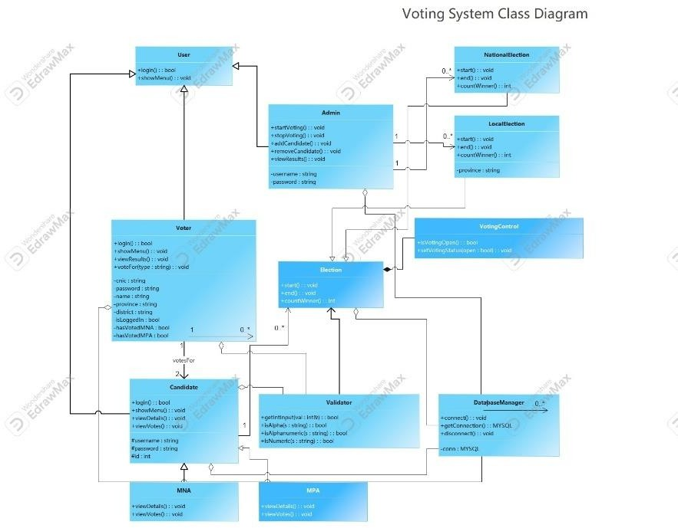

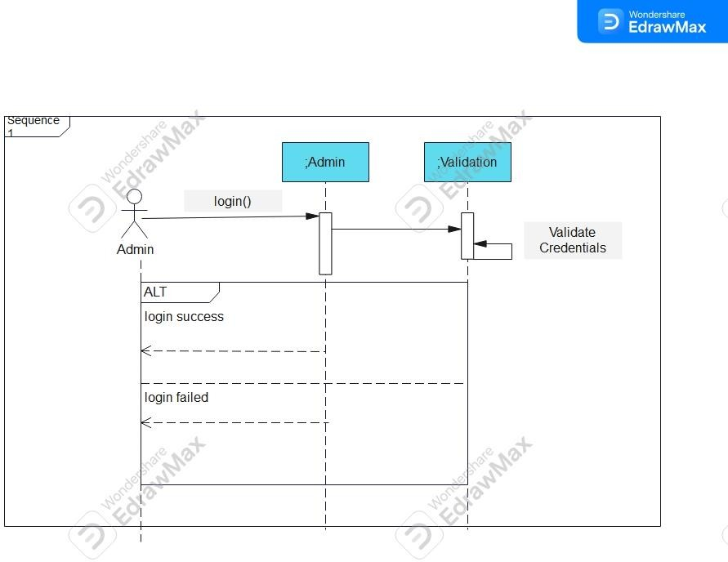
Sequence 1

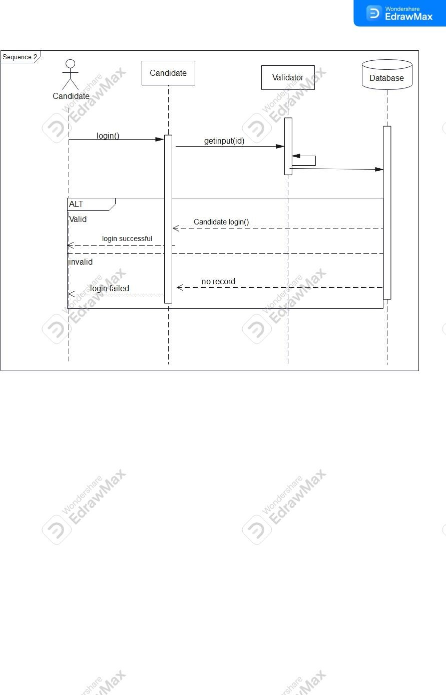

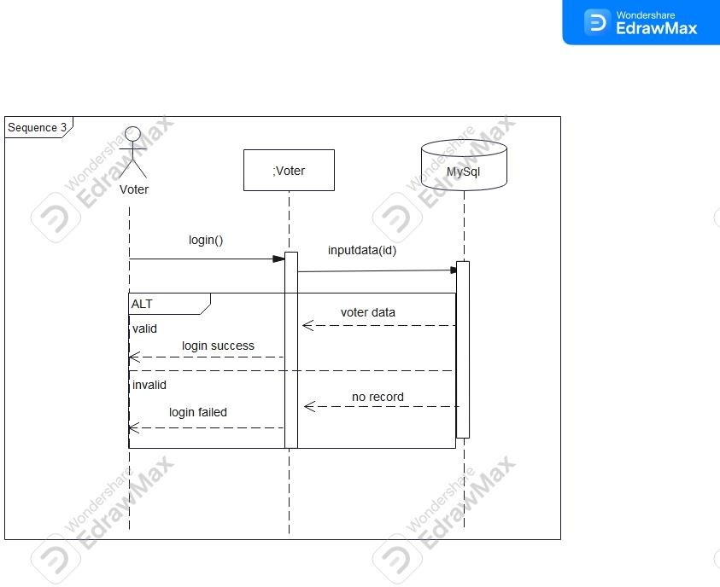

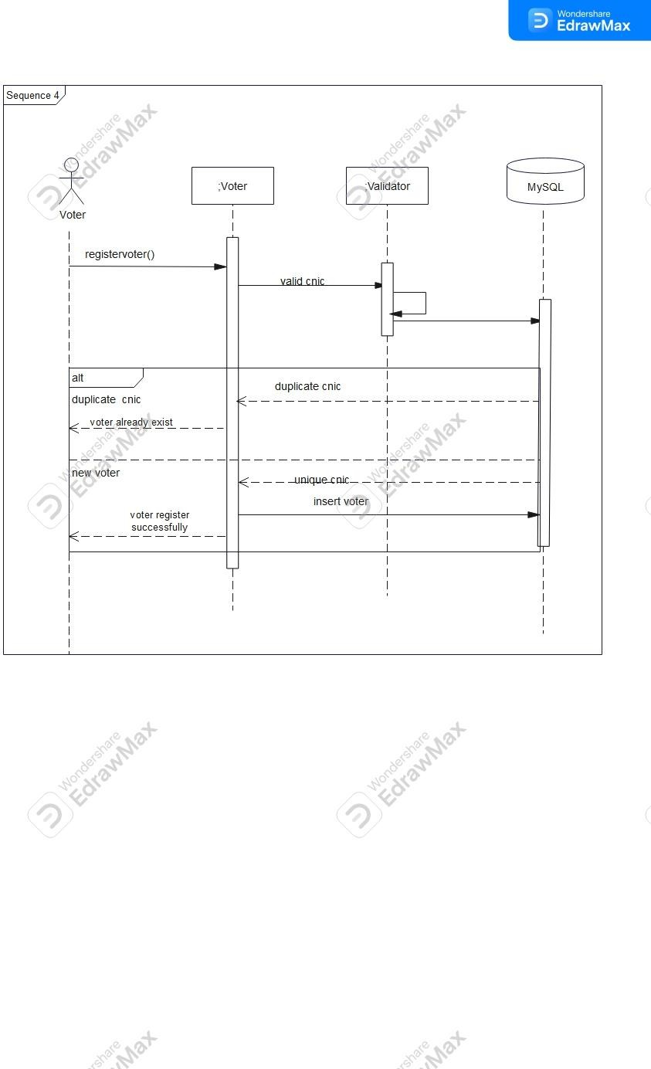

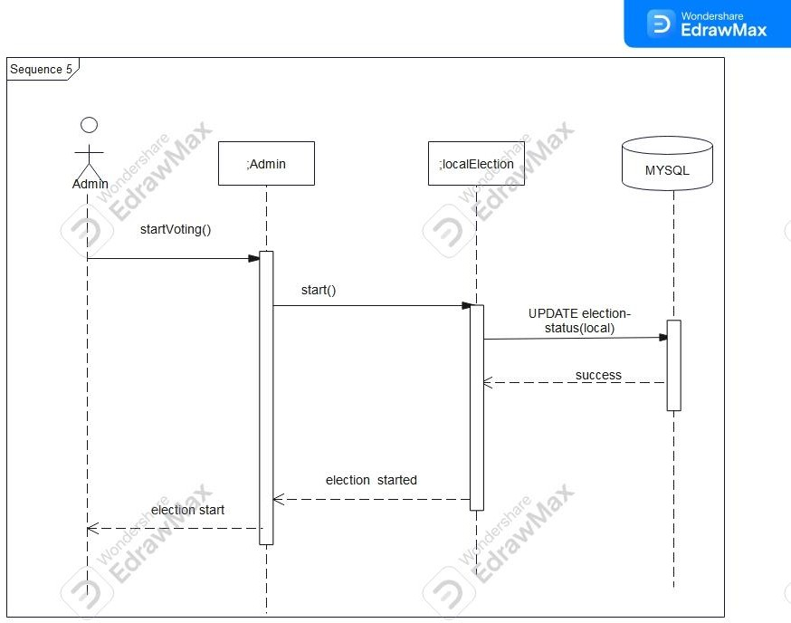

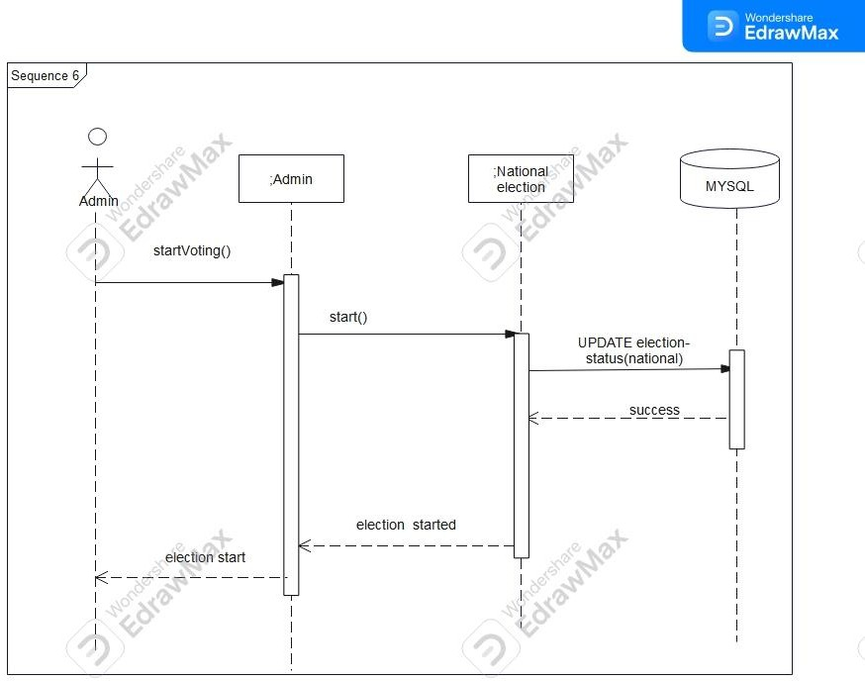

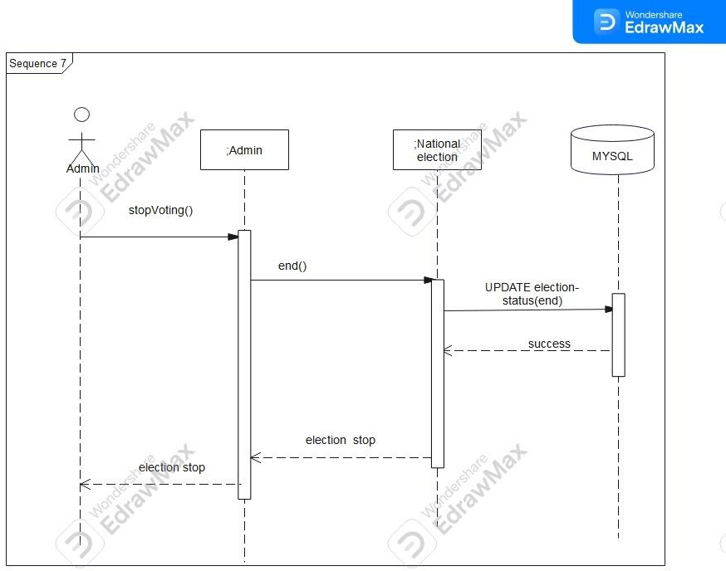

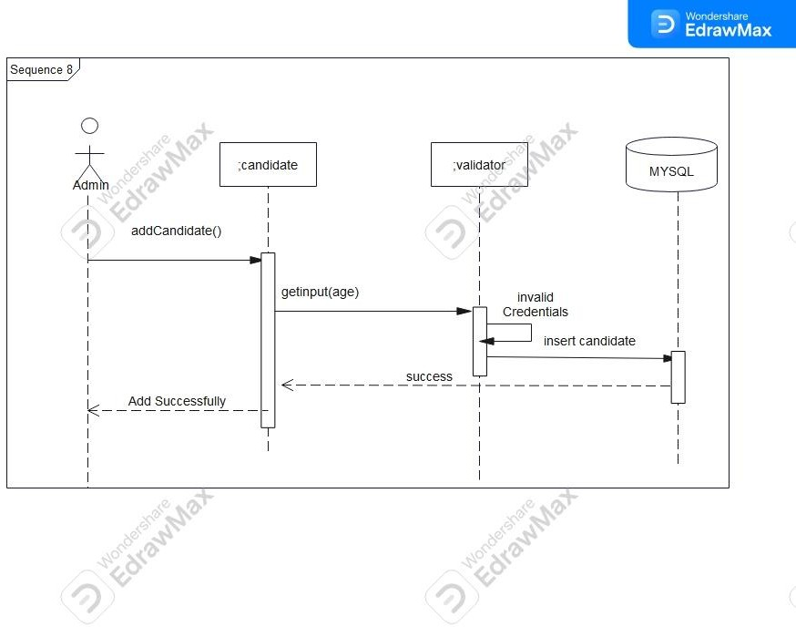

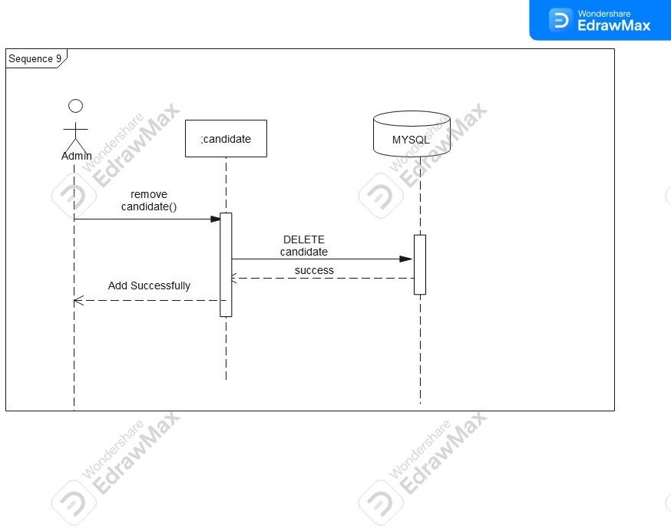

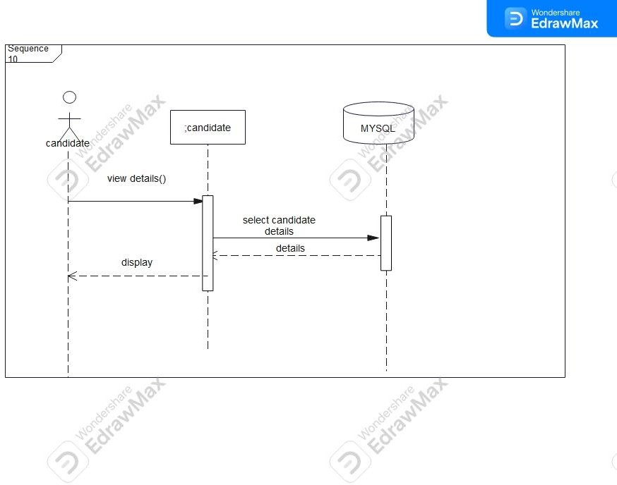

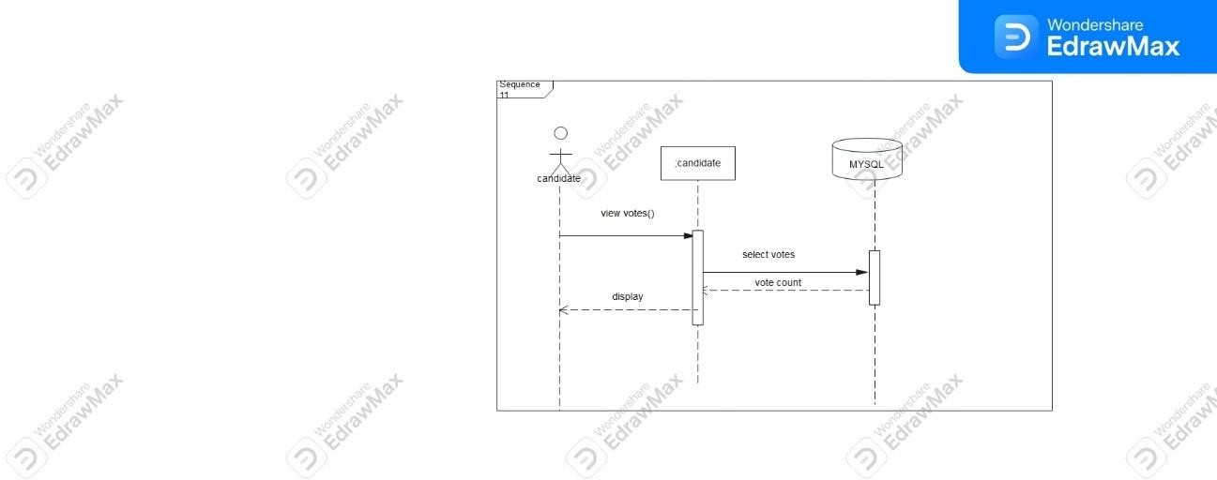
Sequence 11

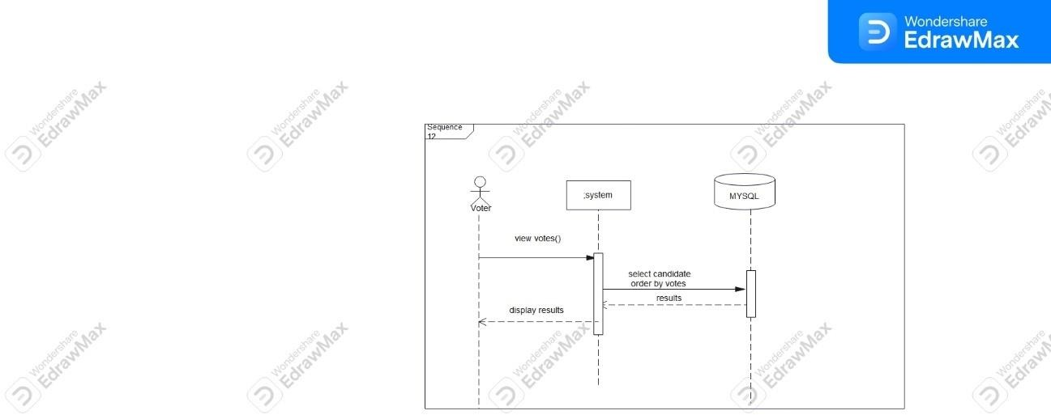

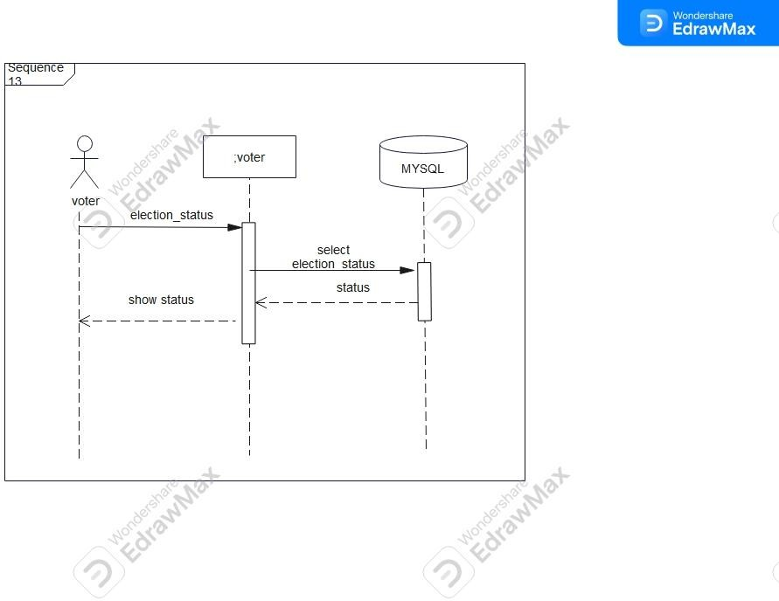
Sequence 13

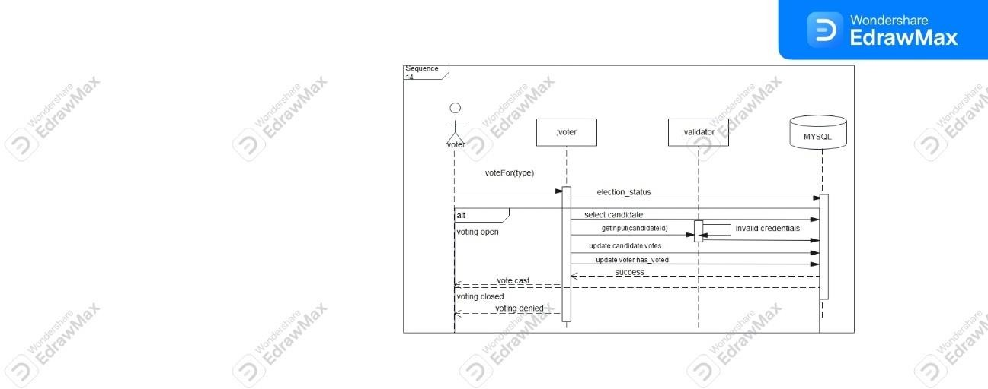

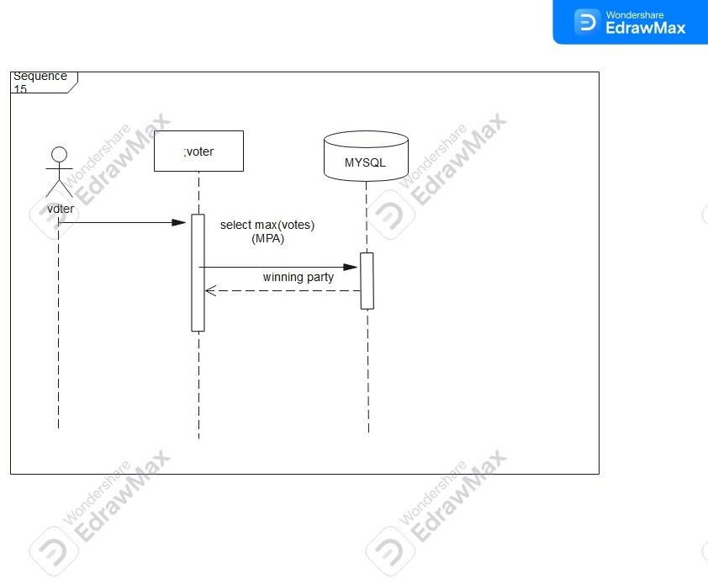
Sequence 15

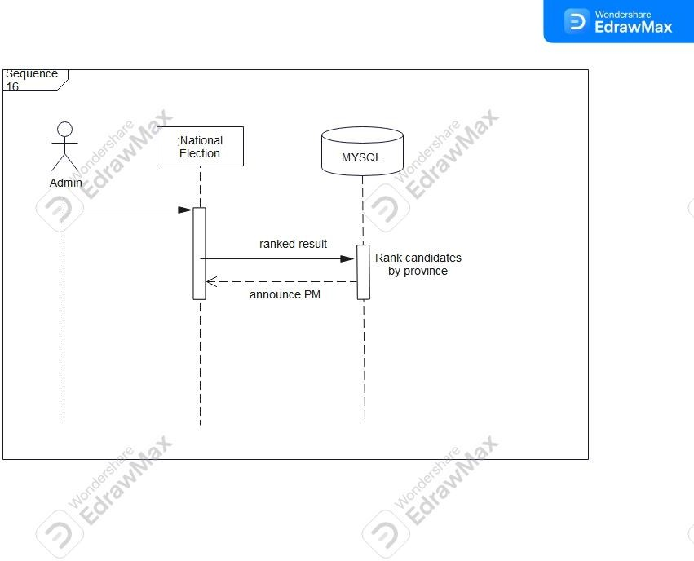

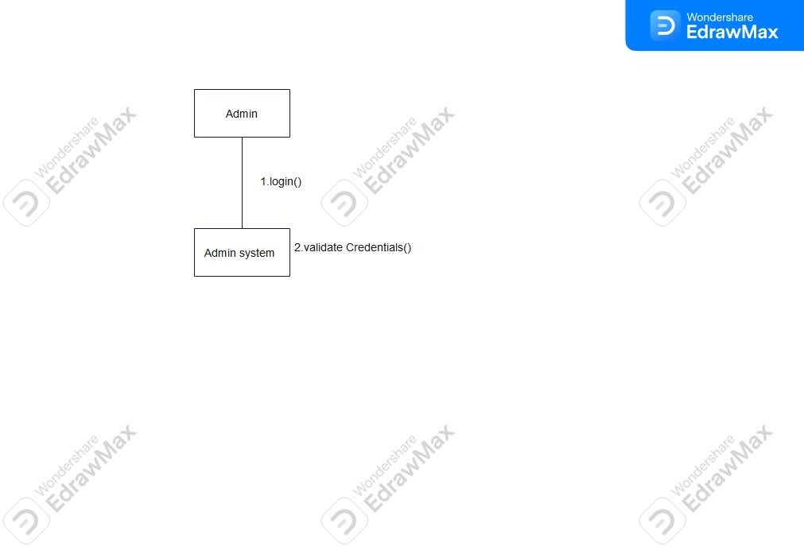
Collaborative 1

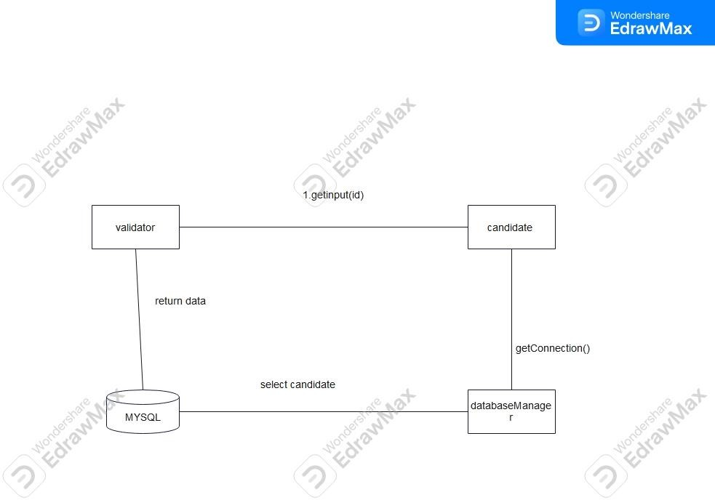

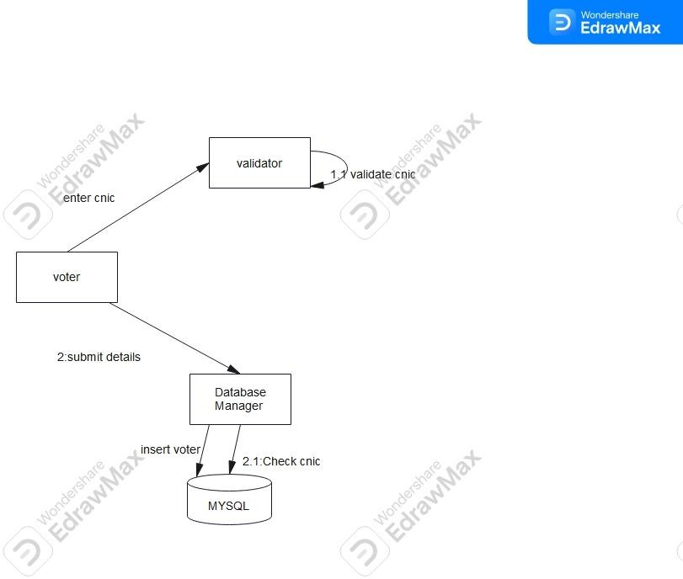

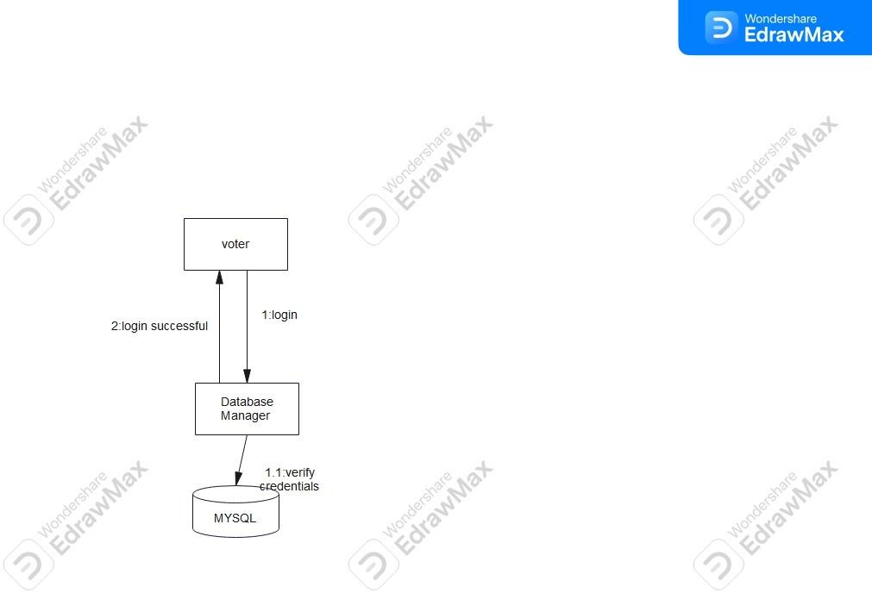

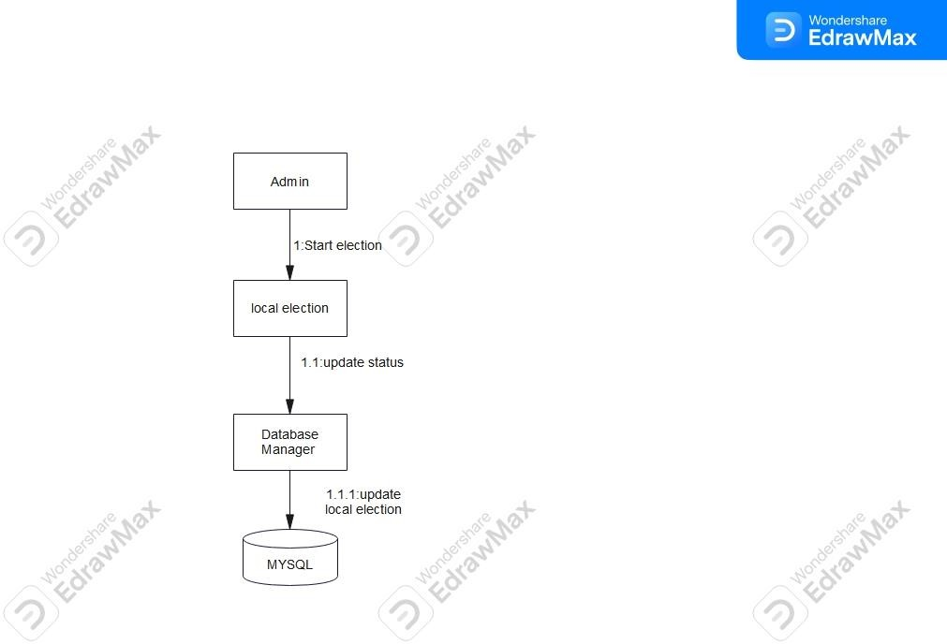

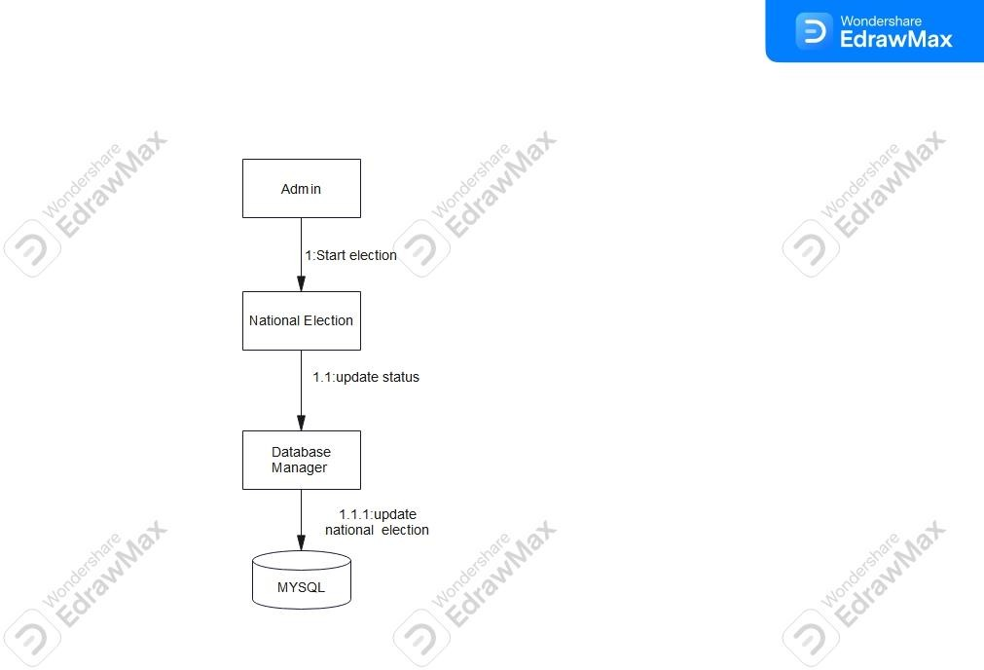

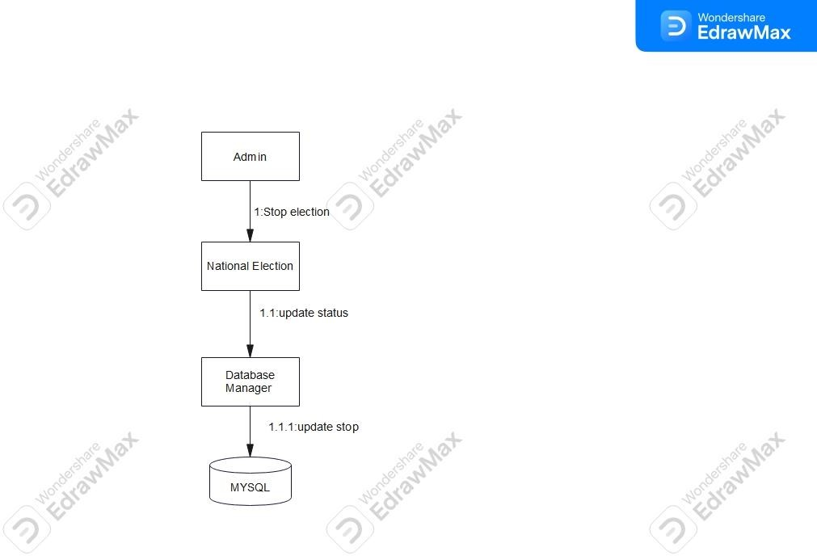

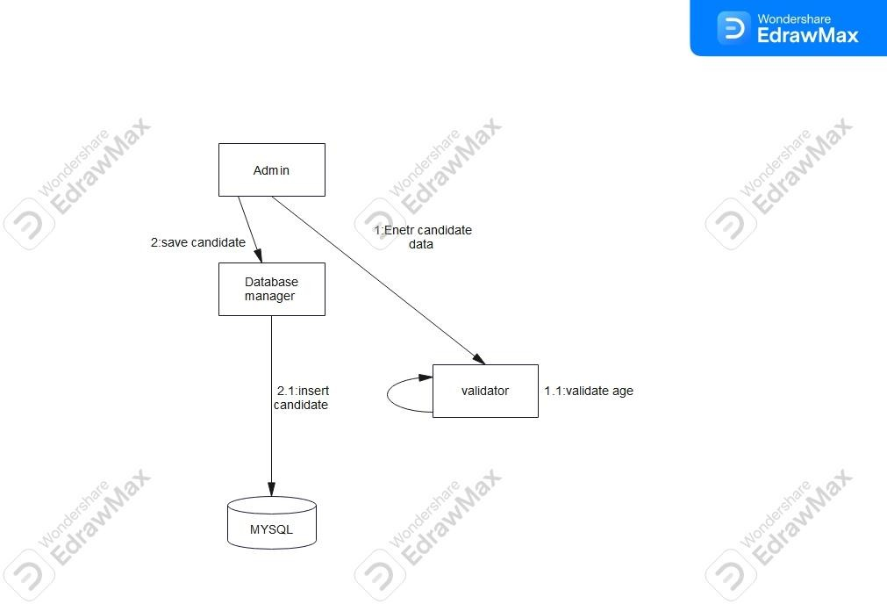

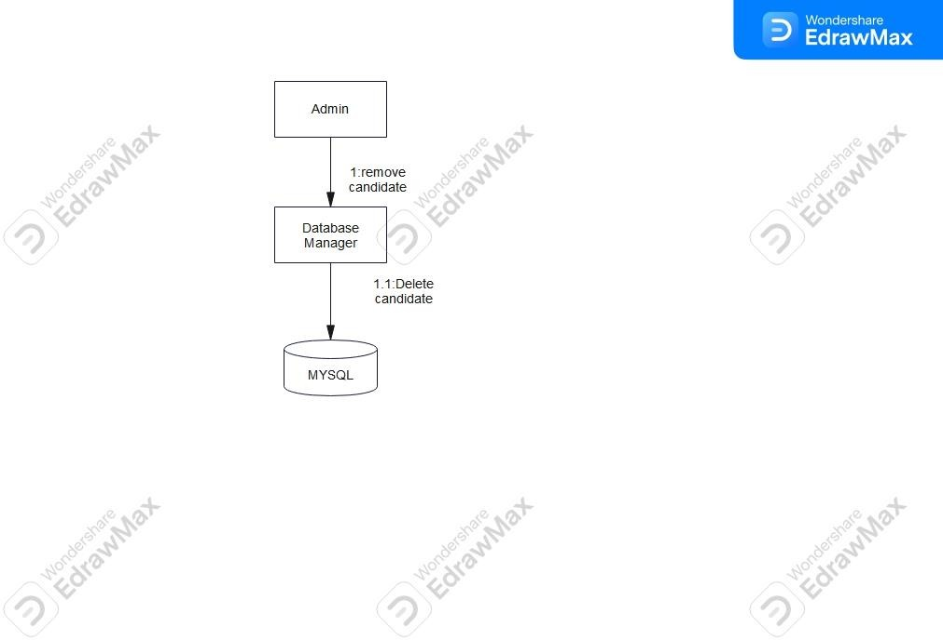
Diagram 9

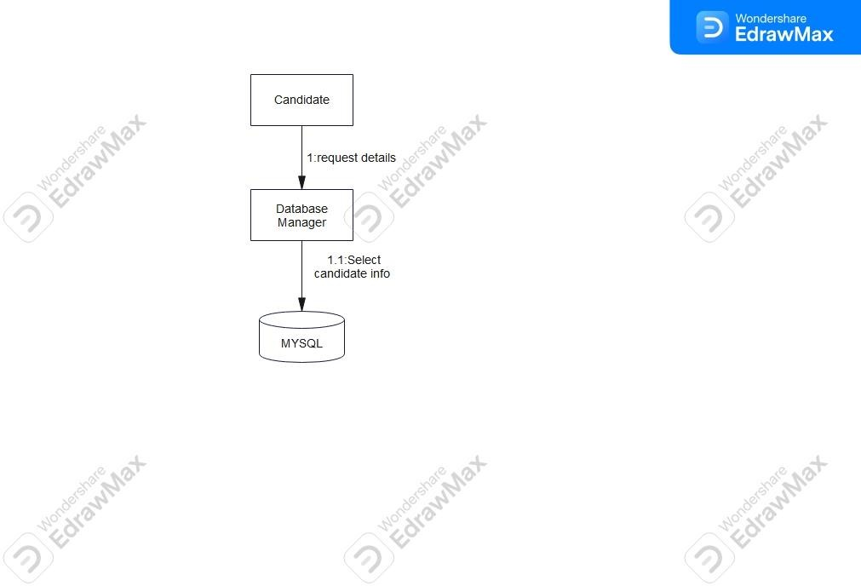

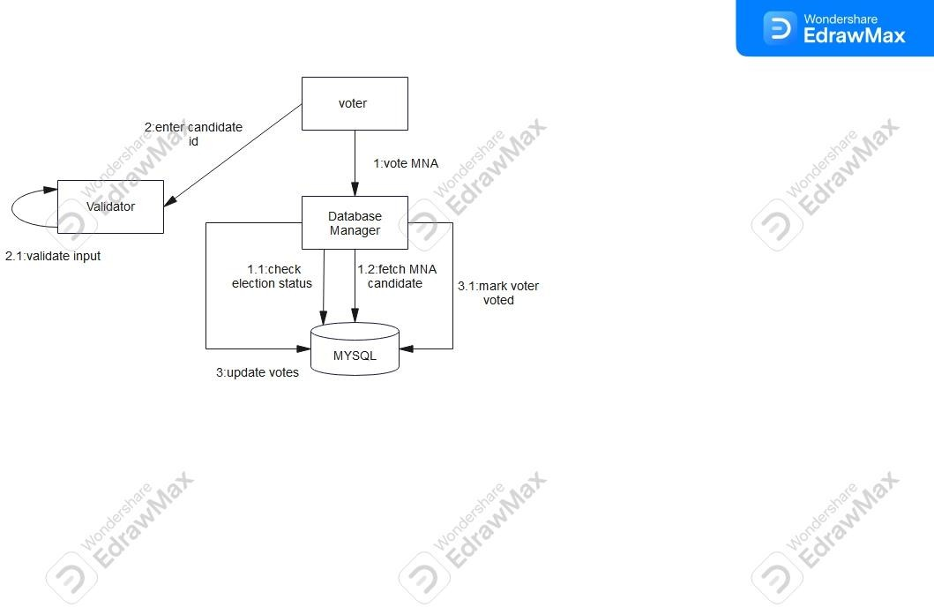

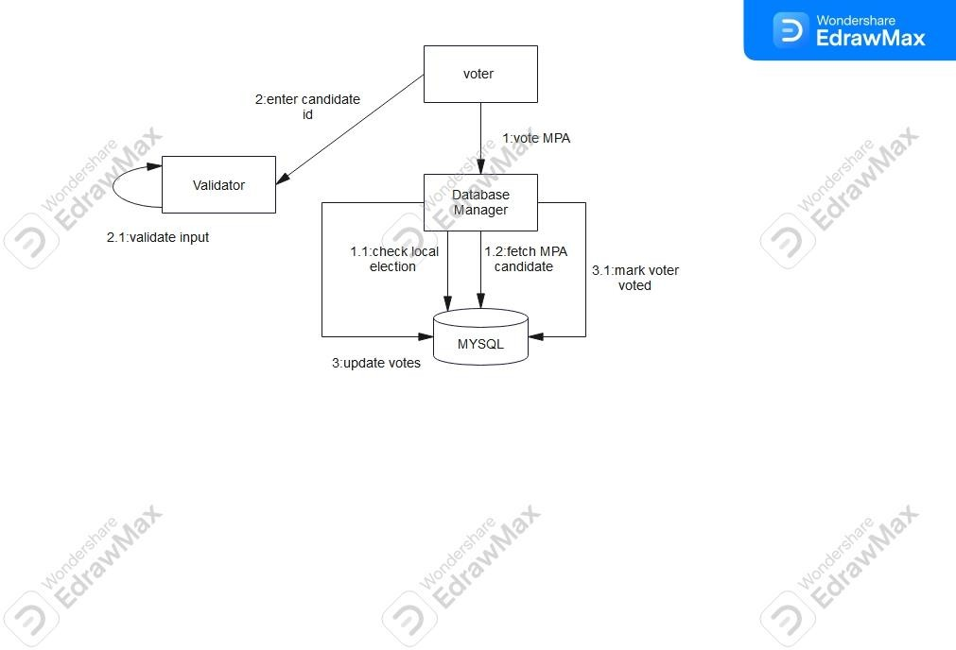

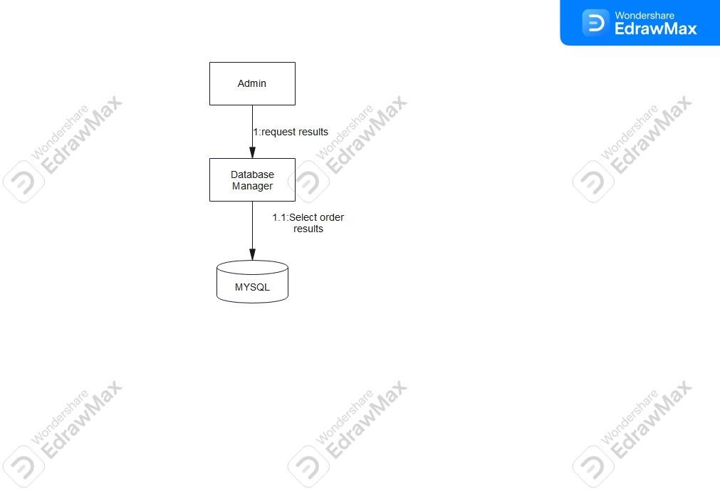

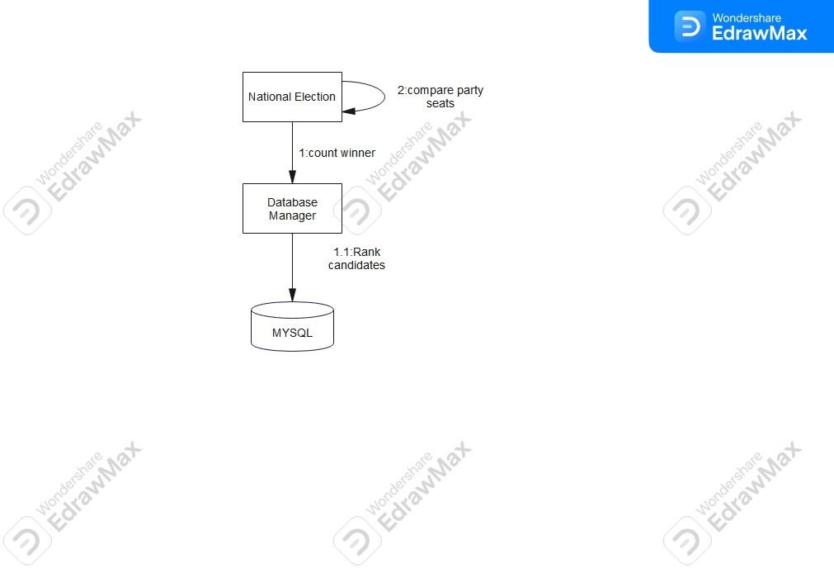

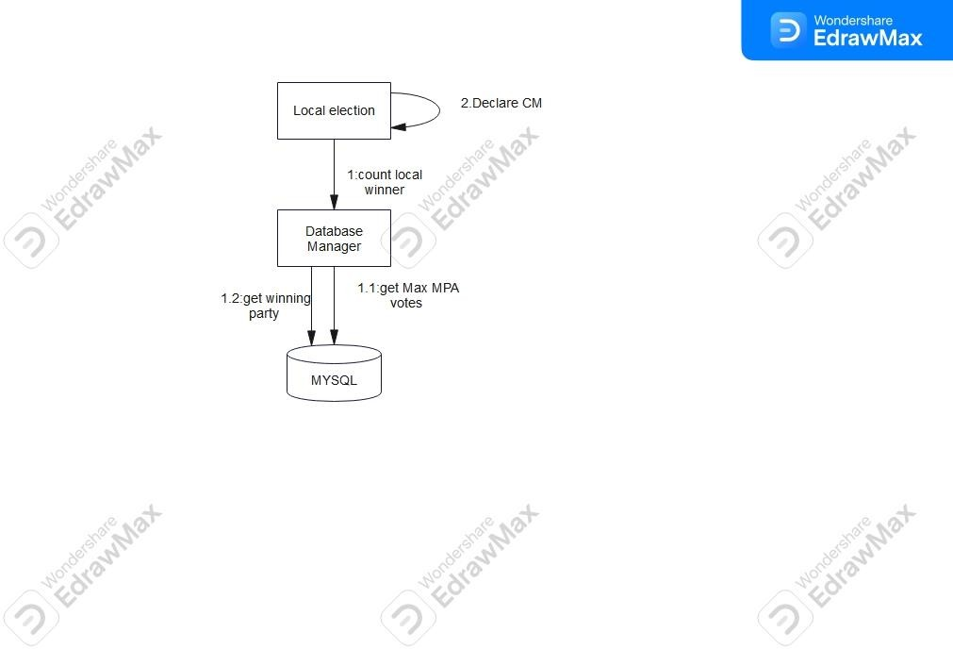

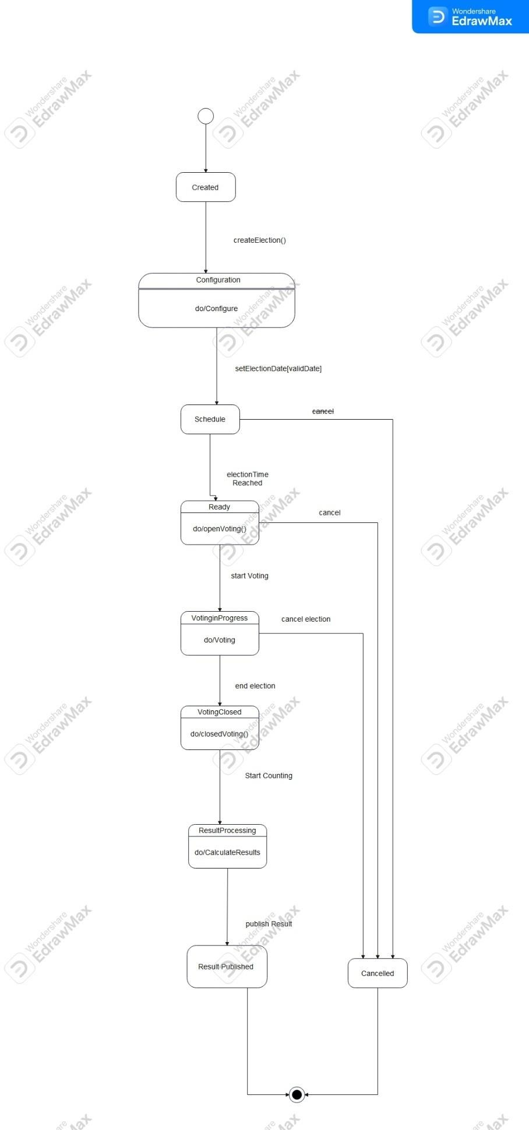
State Diagram

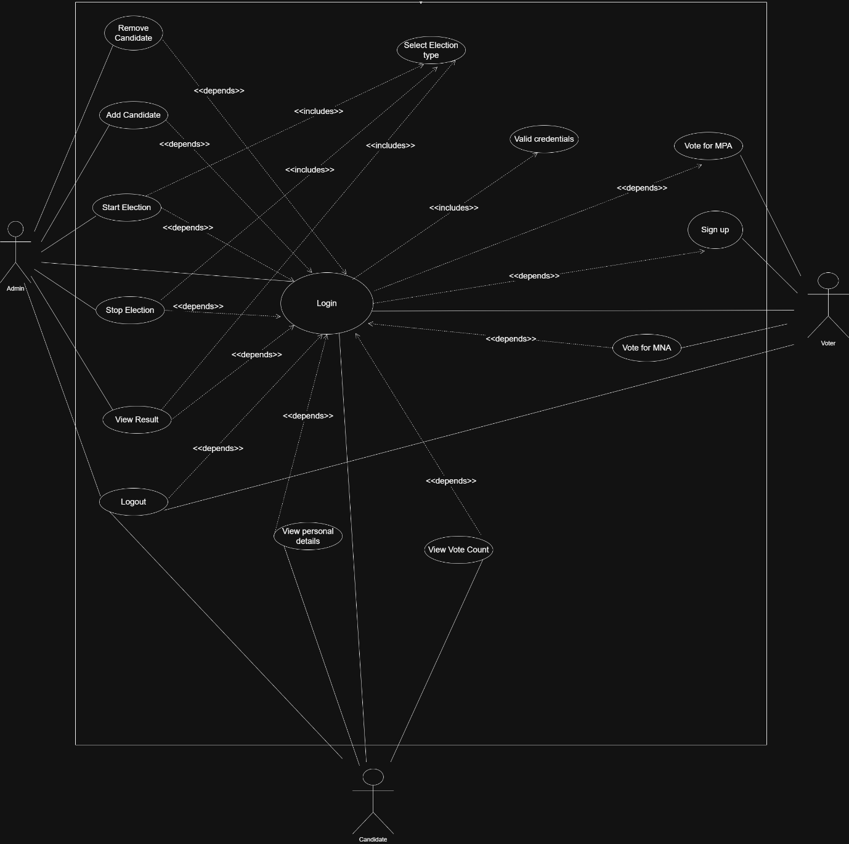
Use Case diagram

Activity Diagrams

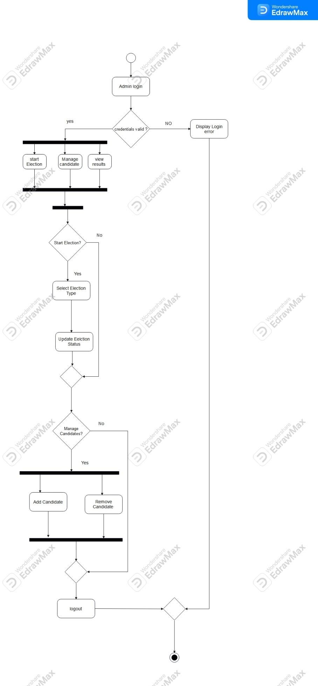
Activity Diagram 1

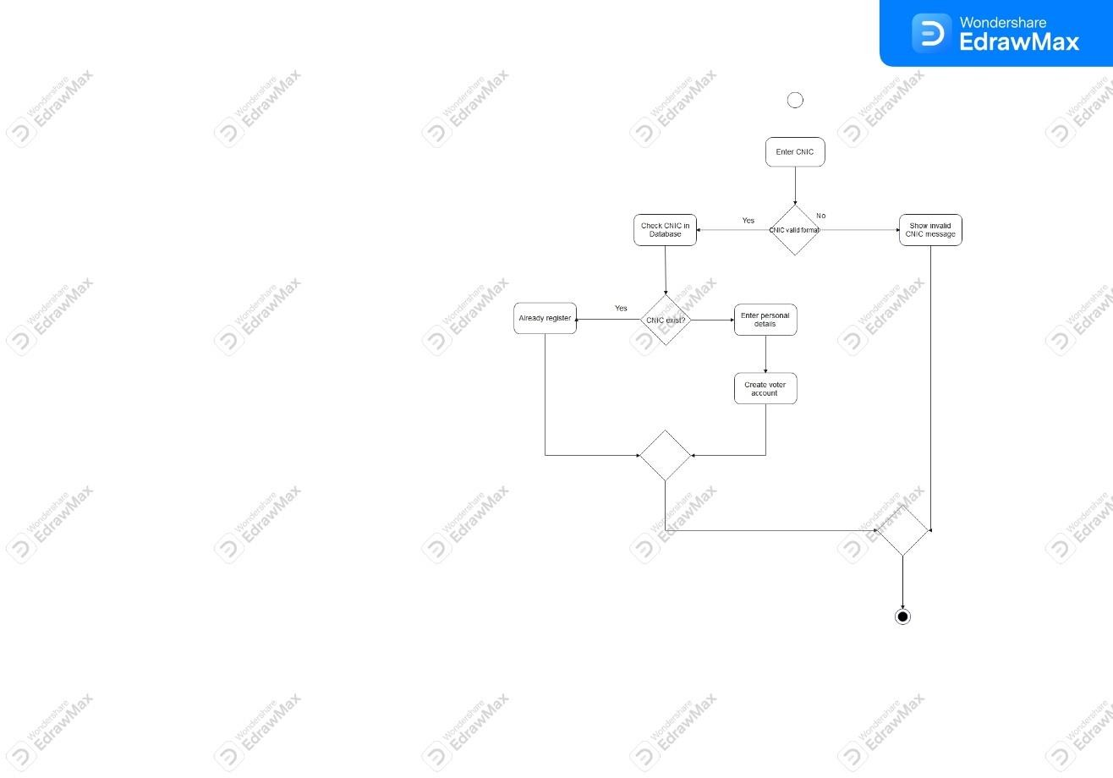

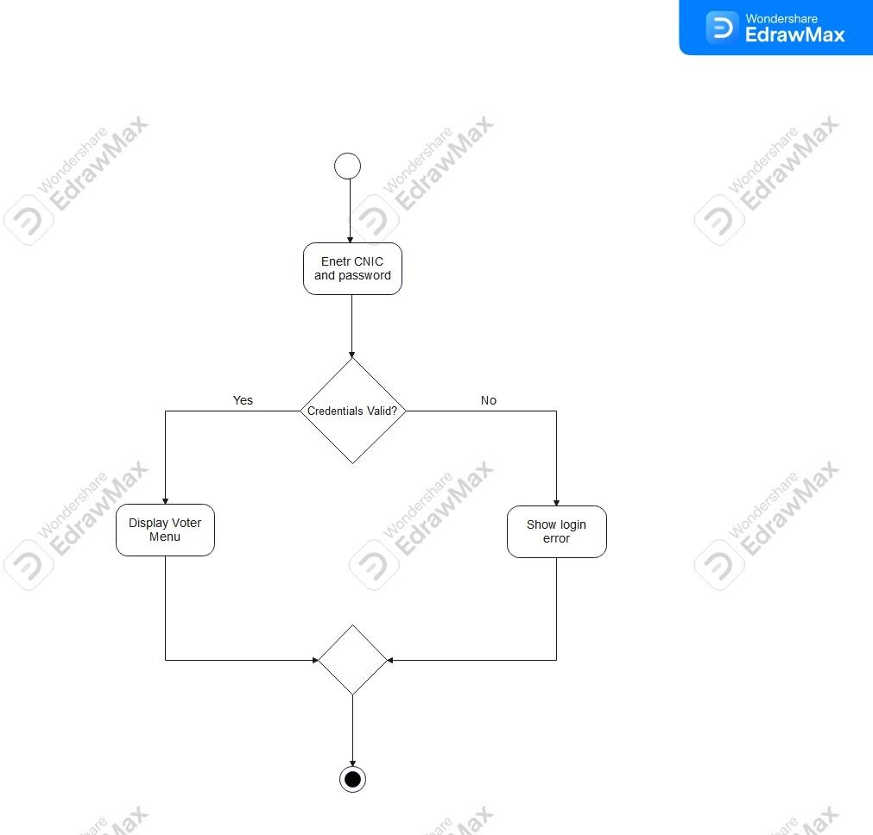

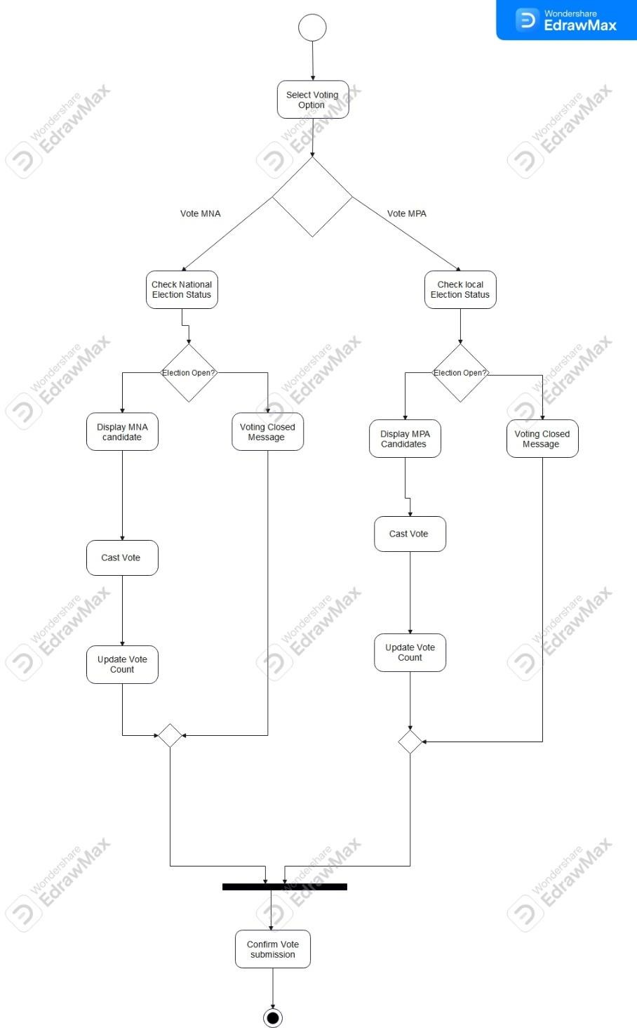

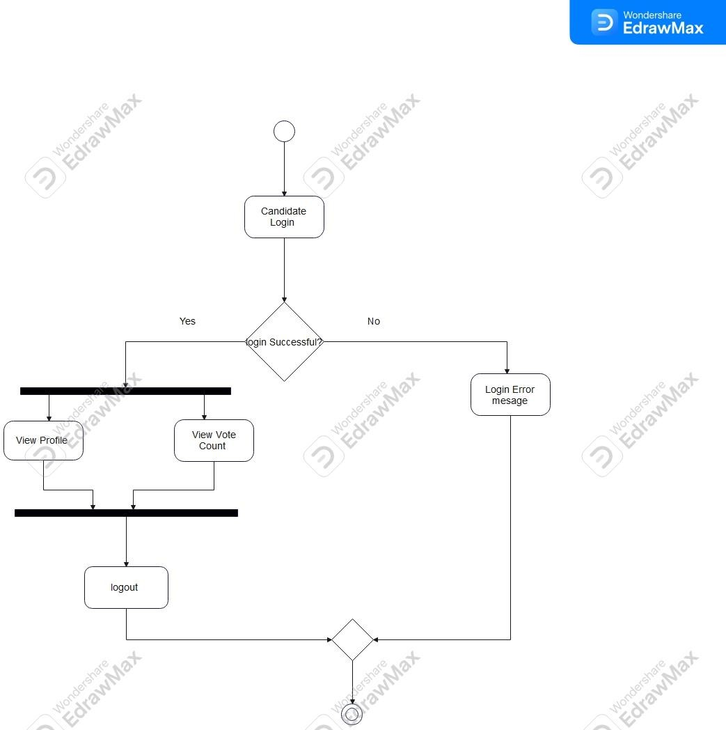

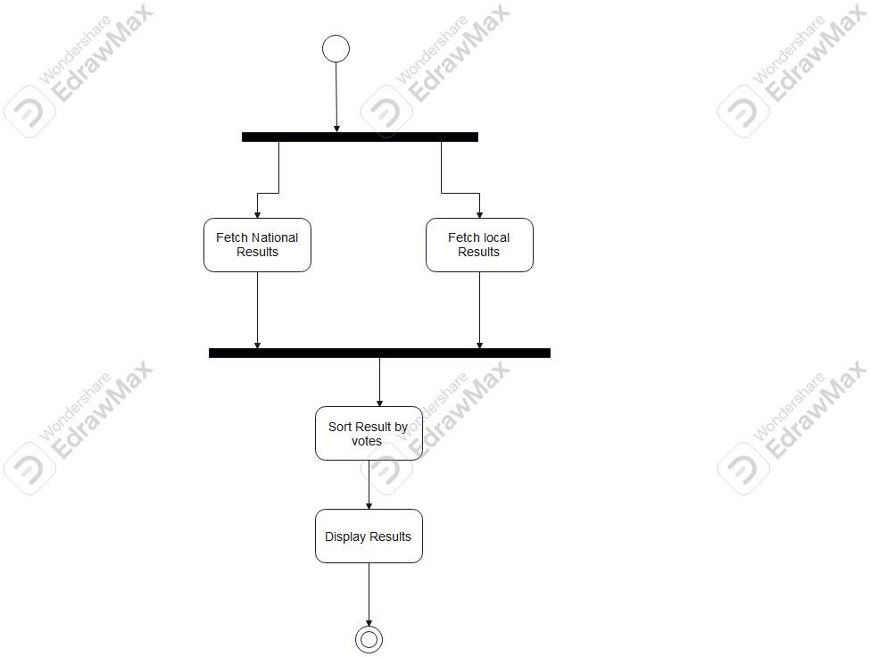

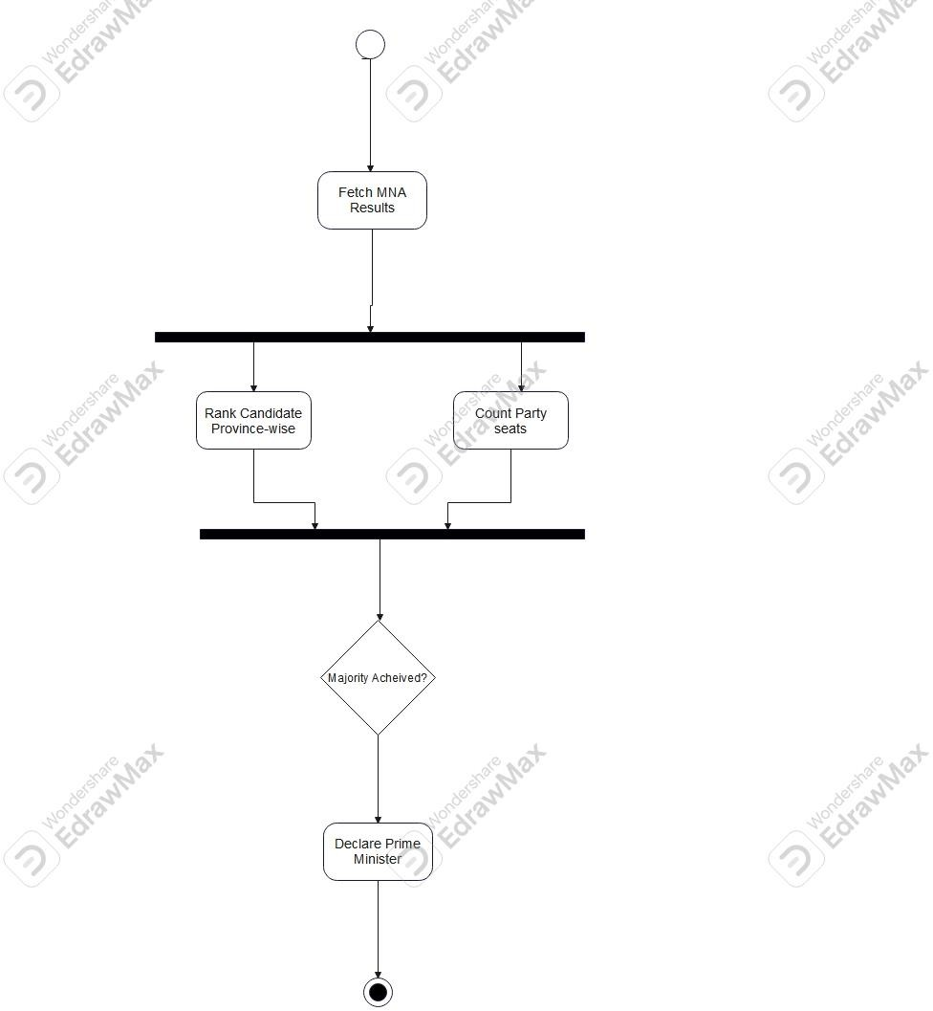

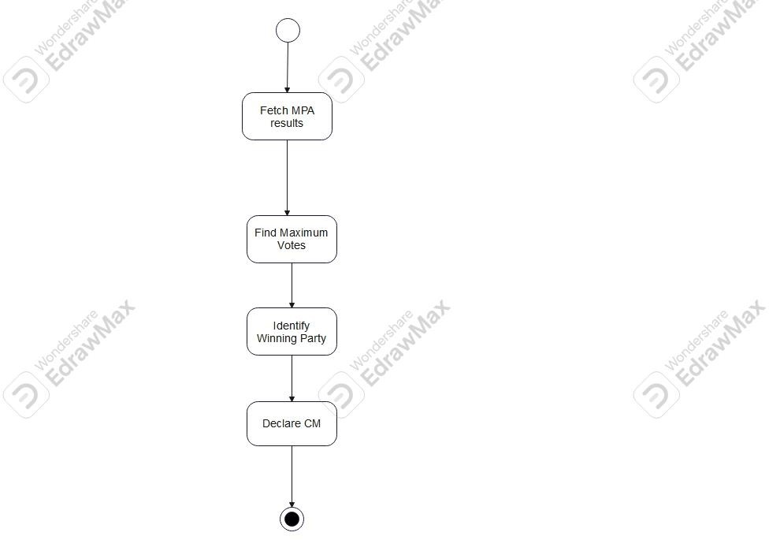

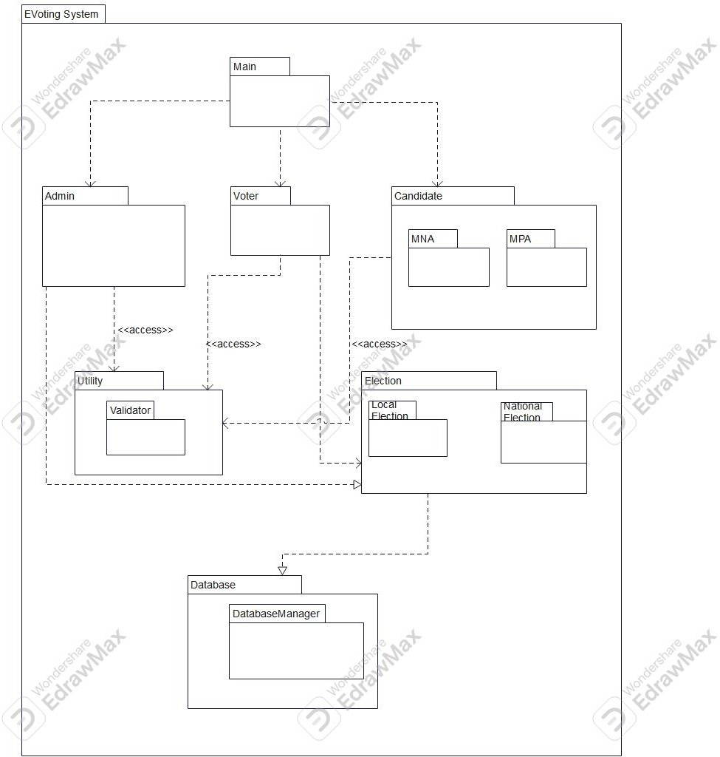

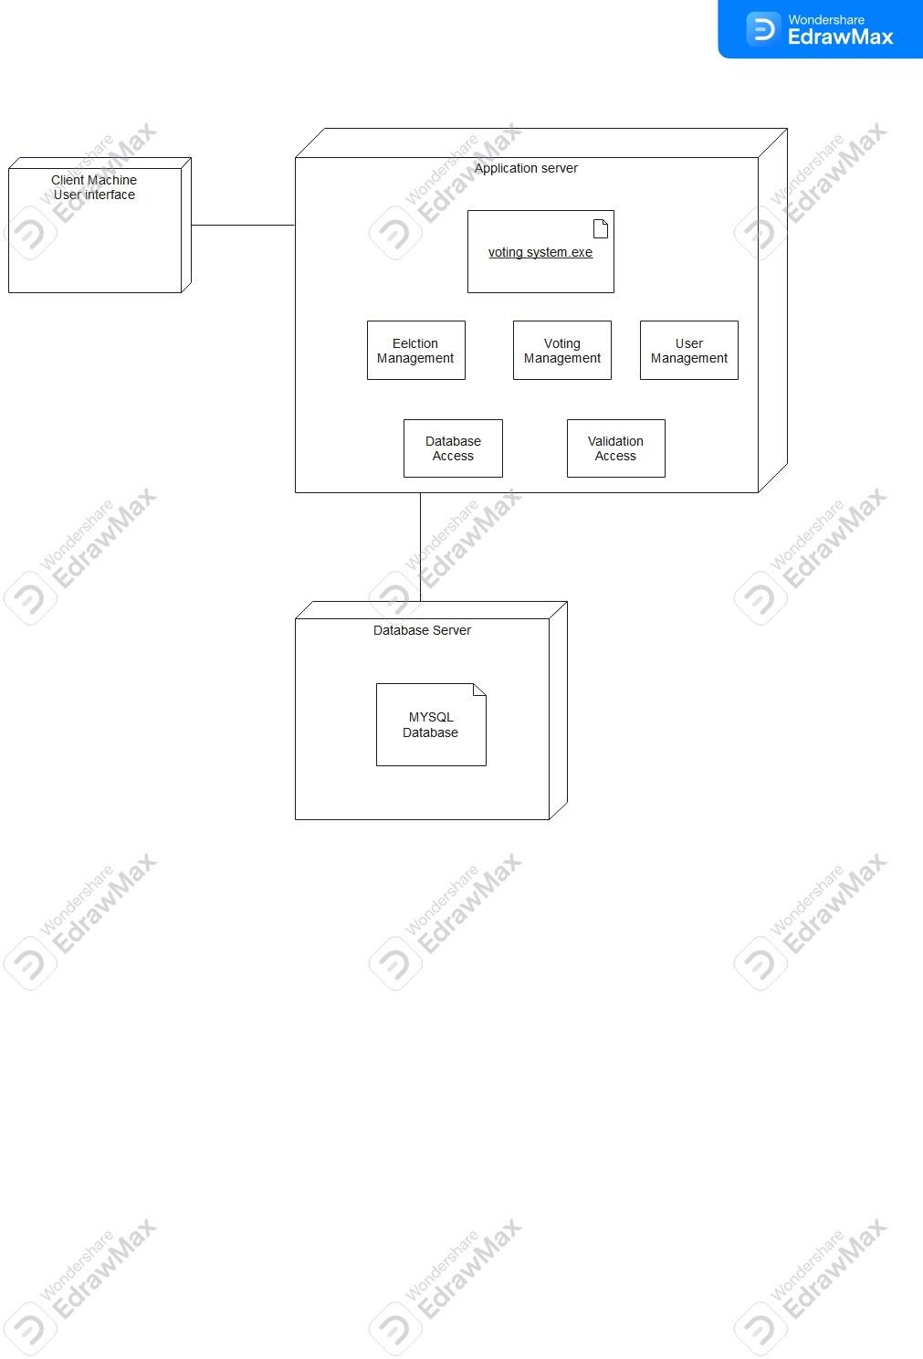

Object Diagrams

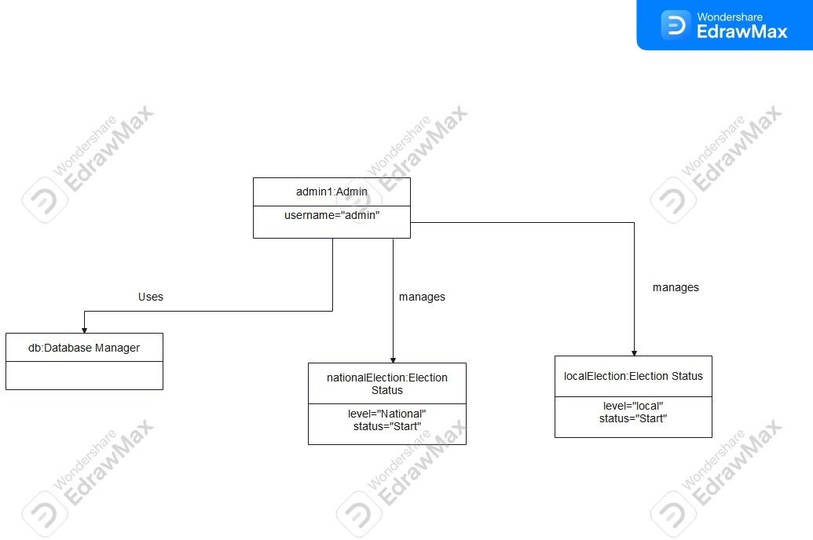
Object Diagram 1

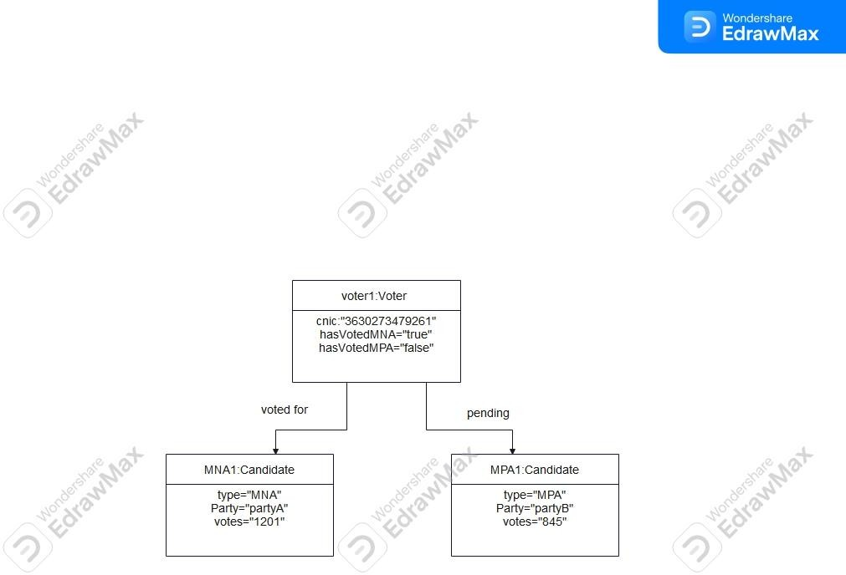

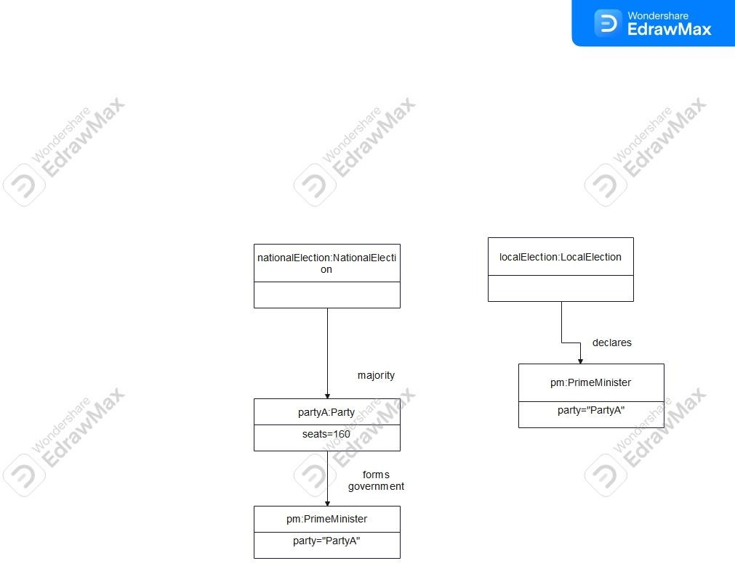

Component Diagram:

